Andie Kantor Bender
ELib 540—Dr. Farmer
Spring 2011

School Particulars – Part 1
- Daniel Webster Middle School, LAUSD.
- Andie Kantor Bender.
- Other library staff: There are several student aides periods 2,3,5, and 6.

Collection Organization – Part 2
The collection is separated into Reference (a group of books cultivated specifically for their connection to content), Nonfiction (arranged by Dewey Decimal System), Fiction (arranged by author’s last name), and Magazines (in plastic covers, but not put in Accent system), in that order around the outer walls. Bookcases are approximately seven feet high, and there are four stools for students to stand on in order to reach the higher books. Books take up all shelves on each bookcase. There is a small section in the center of the library in a wooden display for graphic novels. Additionally, there are five copies of each grade’s textbook on the wall prior to the Reference section for students to use during homework lunch, which takes place in the library daily. In the back room is a professional library as well as an adult lending library for faculty and staff.

The TL orders magazines and keeps them on a bookcase. Students may read them while in the library, but may not check them out. When new magazines arrive, the old ones are placed on a revolving rack. The ones from the revolving rack are placed on a cart and first presented to teachers to take for their classrooms, then to students to take as they will.

The library houses 12 computers for faculty, staff, and student use arranged in three kiosks of four computers each. All three kiosks are located in a row along the south side of the library, in front of the Reference and Nonfiction bookcases. Six computers are in working condition. There is a printer that students can use for a cost of $.10 per page. The school website has links to Accelerated Reader that students often use in the library, as well as a Virtual Reference Desk that the TL has helped to compile.

Flowchart – Part 3

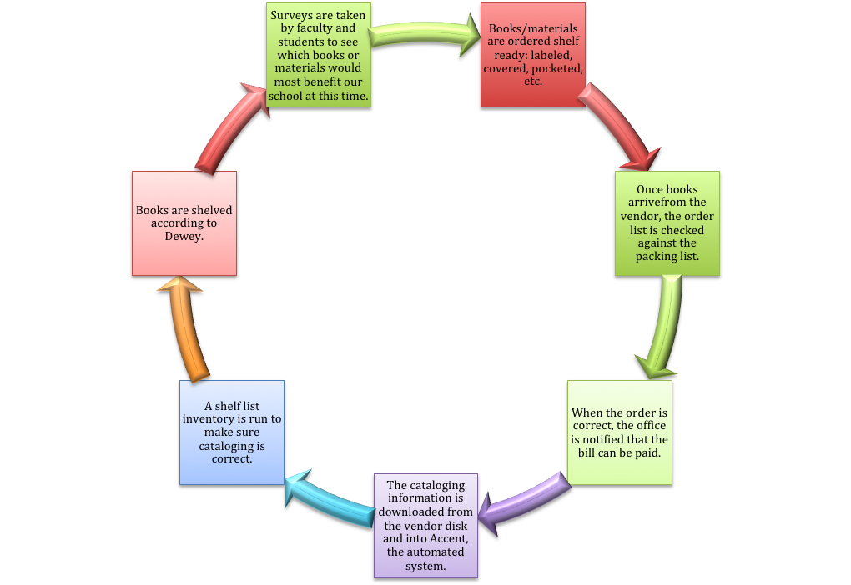

Ordering books completely processed is the most efficient way for me to accomplish all the other tasks for which I am responsible. Inventory and weeding are done sporadically throughout the year in sections. If the library is not being utilized for a couple of days, I might decide to inventory the biography section for example. The same goes for weeding books—I’ll pick a section or a shelf and go over it carefully. This takes place throughout the year. I find it to be an effective method because it happens on a continuous basis.

Vendor Processing File Review—Part 4

Daniel Webster Middle School ‘s cataloging process has changed many times in the last few years. When I took over in 2009, it was unorganized in that each vendor had different specs from the others. This made processing difficult. With the little knowledge I had—and a large dose of common sense, as I hadn’t taken this class yet—I was able to put together something that made sense to me. I have requested the follow specs from Mackin, Follet, and Permabound, which are the three vendors I use.

Subject Headings
Sears/Dewey Decimal System

Nonfiction
Dewey # with first 3 letters of author’s surname

Individual Biography
921 with first 3 letters of biographee’s surname

Collective Biography
920 with first 3 letters of author’s surname

Fiction
FIC with first 3 letters of author’s surname

Easy Fiction
Same as Fiction

Easy Nonfiction
Same as nonfiction

Short Stories
Dewey # with first 3 letters of author’s surname

All Juvenile
No special identification

Author Letter Capitalization
Capitalize all letters

Reference
REF above Dewey #, with first 3 letters of author’s last name underneath

Professional
PRO above Dewey #, with first 3 letters of author’s last name underneath

Catalog Cards
None in library

Circulation Card
Yes

Mylar Jacket
Taped on all books with dust jackets

Clears
None

Kapco
Do not install

Pockets
Fastened to inside front cover

Self-Adhesive Due Date Slip
Fastened to pocket

Spine Labels
Yes, 2” from bottom book edge

Theft Detection labels
3 M

Ownership/Barcode Labels
Title of Book
Daniel Webster Middle School
Los Angeles Unified School District

Barcode labels
Yes

Number Range
Dependent on vendor

Barcode Label Placement
Horizontal GP
Vertical FM

MARC Records
YES!!!!!!!!

System Interface
Accent

Computer Compatibility
IBM and MAC, preferably web-based.

Method of Download
Internet

Accelerated Reader
Yes and small. No special AR sticker.

Written Policies/Procedures – Part 5

I have found no written policies other than what LAUSD Library Services has provided in the Teacher Librarian’s Handbook, which are all on the Library Services website in a hodge-podge manner. Here are some of the policies/procedures found there.

- Library Services
http://notebook.lausd.net/portal/page?_pageid=33,507495&_dad=ptl&_schema=PTL_EP

2. A user’s guide for the latest, up date to CLAS, as well as policies and procedures. (2006)
http://notebook.lausd.net/pls/ptl/ptl_apps.nbk_doc_info.docinfo?p_doc_id=258137

3. A guide to accepting donations for the library of recreational reading books and materials. (2004)
http://notebook.lausd.net/pls/ptl/ptl_apps.nbk_doc_info.docinfo?p_doc_id=152147

4. Procedures for Reviewing Challenged materials (2010)
http://notebook.lausd.net/pls/ptl/docs/PAGE/CA_LAUSD/FLDR_ORGANIZATIONS/FLDR_INSTRUCTIONAL_SVCS/BUL-5208%20CHALLENGED%20MATERIAL%20WORK%207-29-10.PDF

5. Criteria for Evaluating Instructional Materials and Off-Site Instructional Activities (2010)
http://notebook.lausd.net/pls/ptl/docs/PAGE/CA_LAUSD/FLDR_ORGANIZATIONS/FLDR_INSTRUCTIONAL_SVCS/BUL-%205209_CRITERIA%20FOR%20EVALUATING%20INSTL%20MATRLS%207-29-10.PDF

6. Remittance of Library Fines and Reimbursement for Lost/Damaged Books (2008)
http://notebook.lausd.net/pls/ptl/docs/PAGE/CA_LAUSD/FLDR_ORGANIZATIONS/FLDR_OFFICE_OF_CFO/LIBRARY%20FINES%20BULLETIN.PDF

7. Guidelines for the Use of Audiovisual Materials Not Owned, Broadcast, or Recommended by the District (2010)
http://notebook.lausd.net/pls/ptl/docs/PAGE/CA_LAUSD/FLDR_ORGANIZATIONS/FLDR_INSTRUCTIONAL_SVCS/BUL-%205210%20AV%20GUIDELINES%207-26-10.PDF

8. District Standards for School Library Media Centers (2008)
http://notebook.lausd.net/pls/ptl/docs/PAGE/CA_LAUSD/FLDR_ORGANIZATIONS/FLDR_PROF_DEVELOPMENT_LEADERSHIP/BUL-4399%20DISTRICT%20STANDARDS%20LMC.PDF

Benefits and Drawbacks of Processing Practices and Policies – Part 6

I love vendors who process books for me. MARC records, stickering, trying to get the things straight so they look professional—I really dislike it all! So I stick with those vendors who process the books. I love opening up a box of brand new books with all their stickers and introducing them to my students. I don’t shelve new books right away; I display them around the library so that students have an opportunity to browse for a week or so before a book is put in it’s proper place. Additionally, I truly enjoyed the process of changing around my specs, although I did get a bit confused a couple of times, as I didn’t know all the lingo necessary. It’s nice to have autonomy there. Purchasing shelf-ready books and having my own say as far as specs are concerned are definitely benefits to processing.
I have to say that it’s quite frustrating to have a bunch of memos to look up online, in no clear order. I wish there were a tidy booklet—a PDF that could be easily updated—with all this info in a user-friendly setting. Had I not known that Library Services existed—any TL who joined our LAUSD ranks this year might not, as there were no meetings— and not thought to look up the words “Library Services” on the LAUSD website, I never would have found them. In fact, I don’t think I even really knew there was a website with policies and procedures on it. I’ve never looked at it before. Also, the hand-me-down handbook I was given does not seem to have any new information in it, and what I found, with the exception of the purchase order page, is all on the website. Official LAUSD procedures—or lack there of-- are definitely a huge drawback, although I would love to be the person who puts a booklet together!

Reflection – Part 7

After a year and a half in a middle school library, the one thing that has been most helpful to me has been phone calls to other librarians. I never once—with the exception of research for this paper—went online to figure anything out, and when I did, it was frustrating. I have created most of my own policies and procedures from scratch, trying to use logic as much as possible and balance that with the fact that I’m working with middle school-aged children. I have kept a notebook whenever I have spoken to another librarian, which has been extremely useful as a quick reference guide.
Ordering books from a vendor that are shelf ready simplifies things. After having an experience with MARC records myself, I will never order from a vendor who does not do this for me, especially considering that I don’t have any adult support in the library.
When I came to the library, I did not agree with the way the specs were set up. For example, the barcode was on the inside of the book. This did not make sense to me, as it’s easier to scan from the front cover. After very carefully going through the checking in and out process, I changed this, and other things like series with multiple authors being shelved by the first three letters of the series rather than the author, or different manifestations of a work (anime, graphic novel) are all ordered by first three letters of original author’s last name (BAU) instead of traditional Dewey order. This just makes more sense to me.
I still have a lot to learn about our automation program, ACCENT, although I won’t get to, as it will be replaced by Destiny in another month or so. I am hoping and praying that I’ll be trained to use that at some point in the near future, for that will mean that I will get to be a TL again.

